College of Arts and Sciences

Office of the Associate
and Assistant Deans

114 University Hall
230 North Oval Mall
Columbus, OH 43210

614-292-1667 Phone
asc.osu.edu

September 3, 2024

W. Randy Smith, Vice Provost
Council on Academic Affairs
Bricker Hall
CAMPUS

Dear Randy:

I am pleased to endorse the proposal submitted by the Center for Languages, Literatures, and Cultures and the ASL Center for Teaching, Training and Deaf Equity to create a Bachelor of Arts in ASL Access, Equity, and Inclusion. This new major meets a growing student interest in American Sign Language and Deaf Studies, and ensures that as a land grant institution, Ohio State serves the needs of all of its residents, including deaf individuals. This is one of the few programs in the country with such a focus (no such program exists in the Big Ten), and therefore is likely to draw students from beyond the state of Ohio. The major represents a larger effort by the ASL Center for Teaching, Training, and Deaf Equity to respond to the growing interest in ASL teaching and training more broadly.

The proposed curriculum is well designed and accessible. The major does not duplicate any other currently offered at Ohio State and complements other programs in ASC and in other colleges. It has the full support of the College of Arts and Sciences.

Sincerely,

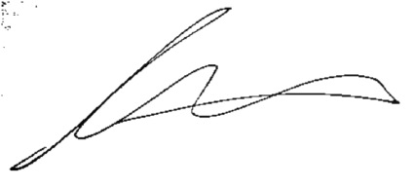

Andrew W. Martin
Associate Dean for Undergraduate Education
Professor, Department of Sociology

